Add Print

Contents

1. Introduction 2

2. Create the printable class 3

3. Configure the main class 5

4. Add the view for print report 6

5. Add JS function 7

# 1. Introduction

The print functional is necessary for printing an automatically rendered document.

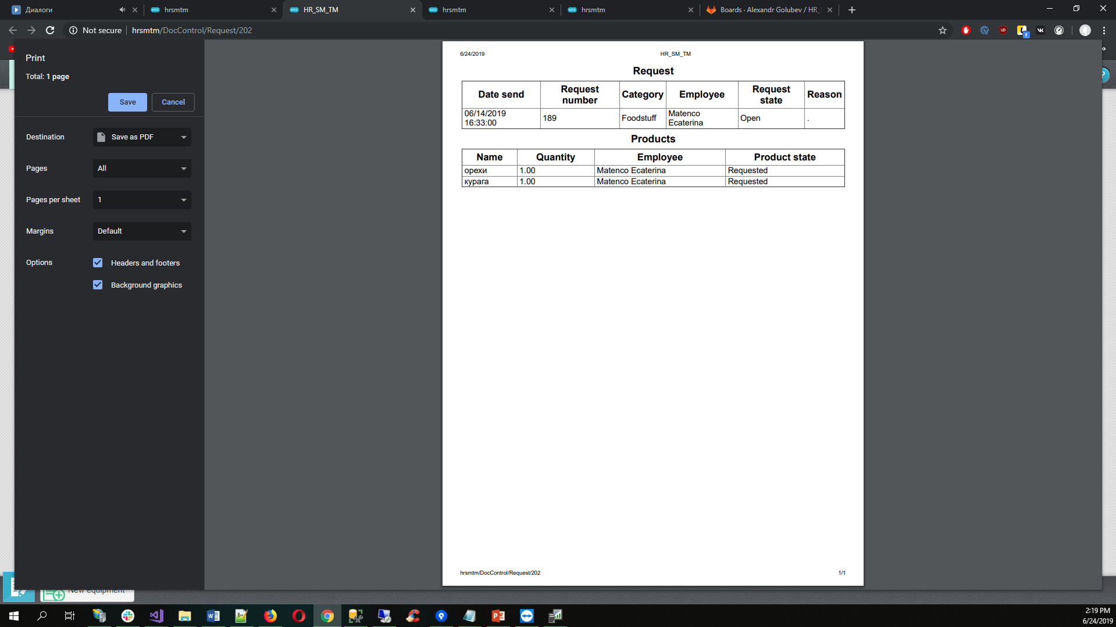

* Rename the names to the necessary in your project

# 2. Create the printable class

1. Add the class **TestPrint** into the path **MedCore \Models\Print\**

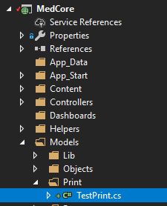

This class will be created in the namespace:

namespace MedCore.Models.Print

2. Add in this class the next code:

public class TestPrint : PrintBase

{

#region Properties

Public Test Test { get; set; }

#endregion

#region Override Methods

public override string LoadReport(ControllerContext ControllerContext, ViewDataDictionary ViewData, TempDataDictionary TempData, ExportType type = ExportType.None)

{

Institution = OrgInfo.LoadCurrentInfo();

Test = (Test)((new Test()).PopulateOne(new Test(Convert.ToInt64(Filters["TestID"]))));

Test.TestState = (new TestState()).Populate(new TestState() { Test = Test });

StylesFile = "meddocuments";

return "TestPrint";

}

#endregion

}

*This class is created as a printable version of your class

# 3. Configure the main class

Add into your class the method:

public override List<iBaseControlModel> LoadContextReports()

{

var ContextReports = new List<iBaseControlModel>();

if (Id > 0)

{

ContextReports.Add(new LinkModel() { Caption = "Test", Action = "print_test_report(" + Id.ToString() + ",'" + typeof(Test).FullName + "')" });

}

return ContextReports;

}

Where TestPrint is the printable version of your class

Action = "print_test_report" – is the JS Function (look №5)

# 4. Add the view for print report

Add the view **TestPrint** into the path **MedCore\Views\Print\**

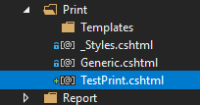

Add the next code:

@model MedCore.Models.Print.TestPrint

@using System.Globalization

@using Weblib.Models

@using Weblib.Models.Common

@using MedCore.Models.Objects

@using MedCoreLib.BusinessObjects

@using Weblib.Helpers

@{

Layout = "~/Views/Master/_Print.cshtml";

}

Add near write the necessary information, which will be displayed on the printable page.

# 5. Add JS function

Add the function into the path **MedCore \Scripts\lib\test.js**

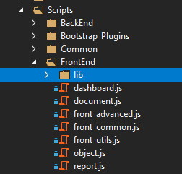

function print_test_report(IdTest, Namespace) {

var postArray = "TestID=" + IdTest + "&Namespace=" + Namespace;

return print(postArray);

}